INSTRUCTIONS: This is an SOP template; it is complete when
1) All form fields have been completed to reflect chemical/lab-specific information, including adding relevant procedure information, or deleted inapplicable information; and
2) SOP has been signed and dated by the PI and relevant lab personnel.
Use safety data sheets (SDSs) as a resource for chemical-specific information. Text highlighted in gray indicates where information should be added or edited. Delete all instructions in red text and “Draft” watermark after the SOP is approved by PI.

Standard Operating Procedure for Compressed Gases
REQUIRED: List chemical(s) and CAS numbers here

Section 1 – Lab-Specific Information
Building/Room(s) covered by this SOP:
Unit or department:
Principal Investigator Name:
Principal Investigator Signature/Date:
This SOP was created by (if not PI):
Name/Title/Date/Signature

Section 2 – Hazards
Compressed gas cylinders hazards are compounded by the volume of gas and the pressures involved. Leaking or vented inert gas can displace breathing air.
REQUIRED -Identify the compressed gases used and the hazards associated with them.
REQUIRED - Describe hazards associated with this/these chemicals
Hazards may include, but are not limited to:
- routes of exposure
- how exposure might occur
- target organs
- signs and symptoms of exposure
- expected by-product(s) if this SOP covers a laboratory process
Obtain hazard information from SDS. Include regulatory information if chemical is a particularly hazardous substance. Use GHS Pictograms to indicate hazards; delete the pictograms that do not apply.
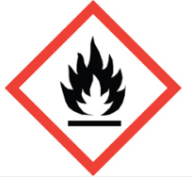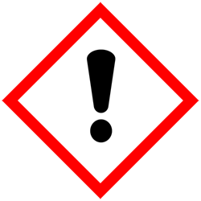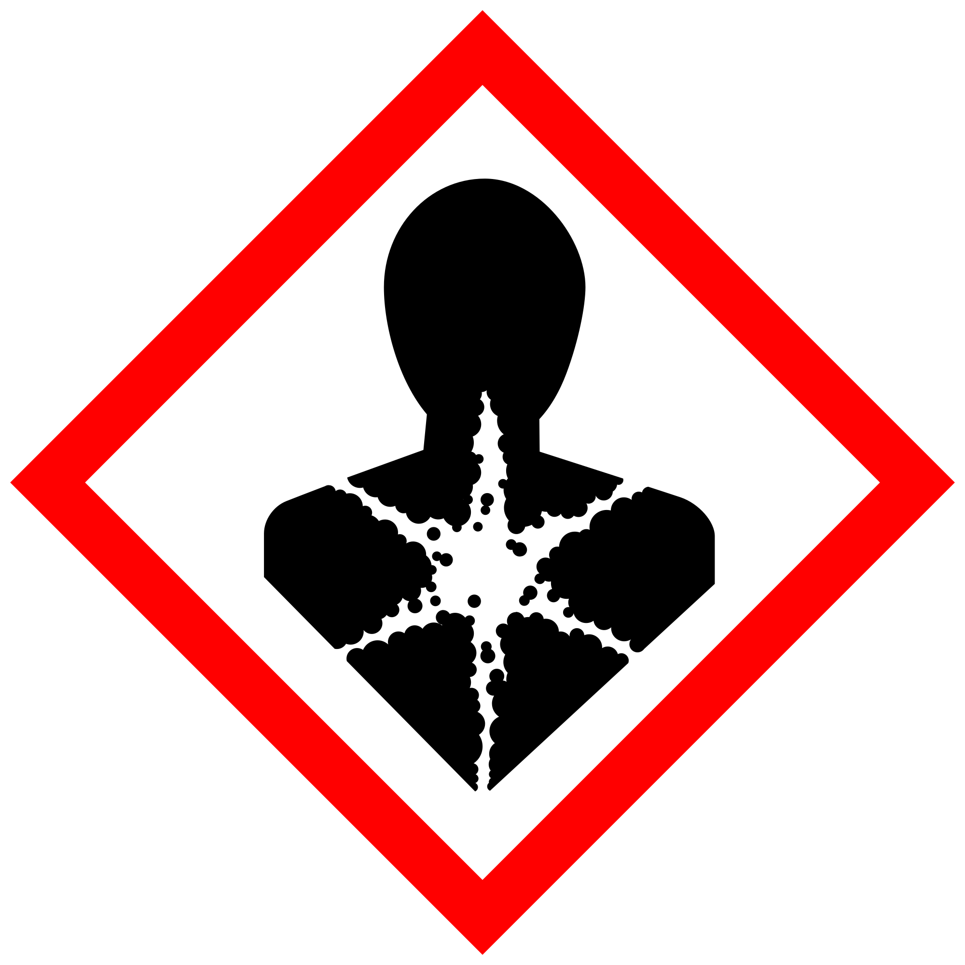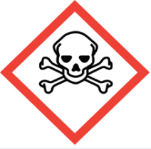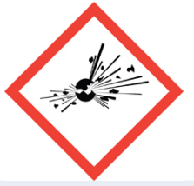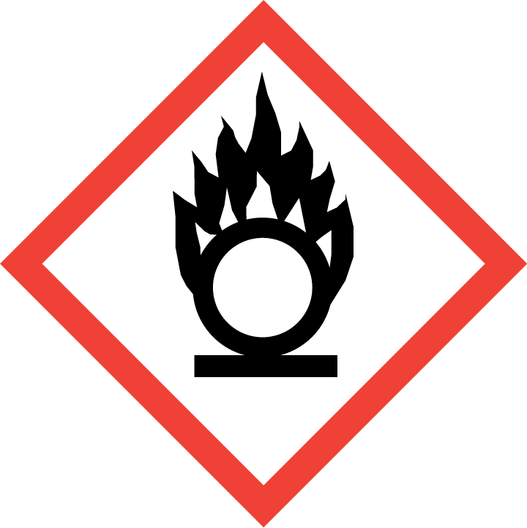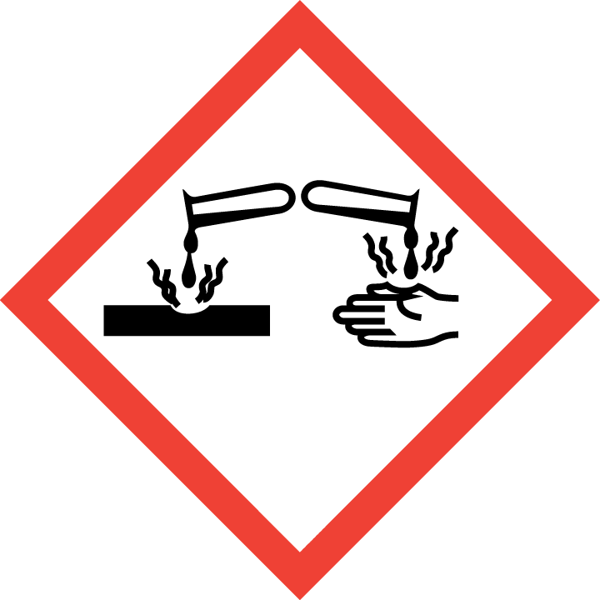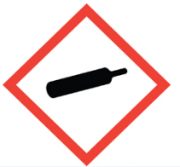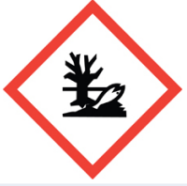

Section 3 – Engineering Controls and Personal Protective Equipment (PPE)
Fittings and connections must be properly tested for leaks using a soapy water, 'Snoop' or other appropriate test system or meter. Do not use an open flame.
Using certain classes of chemicals, including particularly hazardous chemicals (i.e., highly toxic, reproductive toxicity, select toxins, carcinogens, corrosives, strong oxidizers, otherwise dangerous), under certain conditions (e.g., at elevated temperatures) may require facility-specific engineering/ventilation controls. Refer to the chemical SDS and identification of particularly hazardous substances in MyChem. Contact UW EH&S at labcheck@uw.edu for engineering control details.

Engineering controls
REQUIRED - Insert descriptions of lab-specific engineering or ventilation controls used to reduce chemical exposures (e.g.,fume hoods, snorkels, glove boxes, reverse flow laminar benches, biosafety cabinets, etc.) or specific equipment safety features.
Any chemical fume hood used must be tested and passed by EH&S.

Hygiene measures
Avoid contact with skin, eyes, and clothing. Wash hands after removing PPE, before breaks, and immediately after handling the chemical. If chemical name(s) come(s) into contact with any PPE, the PPE shall be immediately removed and discarded properly. Any potentially exposed body parts should be washed immediately.
PPE must be specified completely, such as type, and whether necessary for the entire process or at certain steps. Refer to the chemical SDS(s) and UW Laboratory Safety Manual Section 5.b. for further guidance.

Skin and body protection
Chemically compatible laboratory coats that fully extend to the wrist must be worn and be appropriately sized for the individual and buttoned to their full length. Personnel must also wear full-length pants, or equivalent, and close-toe shoes. The area of skin between the shoe and ankle must not be exposed.
If a risk of fire exists, a flame-resistant laboratory coat that is NFPA 2112-compliant should be worn. Some FR fabrics (e.g., Nomex®, Rhovyl®, Kevlar®, etc.) are highly permeable and do not provide good chemical/acid resistance.
For chemicals that are corrosive and/or toxic by skin contact/absorption additional protective clothing (e.g.,face shield, chemically-resistant apron, disposable sleeves, etc.) are required where splashes or skin contact is foreseeable.
REQUIRED: Specify type of lab coats to be used (if multiple options are available) or list information on chemical-appropriate alternatives, such as chemical aprons.

Hand protection
Hand protection is/is not required for the activities described in this SOP.
NOTE: Consult with your preferred glove manufacturer to ensure that the gloves you plan to use are compatible with the specific chemical being used.
REQUIRED – Specify gloves or combination of gloves that are required. When possible, include the exact manufacturer and model information.
Gloves must be inspected prior to use, including a check for pinholes.
Use proper glove removal technique (without touching glove’s outer surface) to avoid skin contact with this product. Dispose of contaminated gloves after use in accordance with applicable laws and good laboratory practices. Wash and dry hands immediately after glove removal.

Eye protection
ANSI Z87.1-compliant eye protection is/is not required for all work with chemical(s). Ordinary prescription glasses will NOT provide adequate protection unless they also meet the Z87.1 standard and have compliant side shields.
REQUIRED - Specify minimum eye protection required (splash goggles, safety glasses, safety goggles, face shields).

Respiratory protection
Respiratory protection is/is not required for the activities described in this SOP.
REQUIRED - Specify if/when this chemical is allowed to be used outside of a fume hood and if additional respiratory protection is required for such work. Include expectations for completion of respirator fit-testing.
Respirators should be used as a last line of defense (i.e., after engineering and administrative controls have been exhausted), and when any Action Limit (AL) or Occupational Exposure Limit (OEL) has been exceeded or when there is a possibility that an AL/OEL will be exceeded. Respiratory protection may be needed if a dust, aerosol or vapor hazard is present and work is conducted outside of the fume hood. If any procedure may pose an external hazard, it should be eliminated or strictly isolated.
If a potential exposure hazard cannot be eliminated, contact the EH&S Respiratory Protection Program administrator at uwresp@uw.edu, or call 206.543.7388 to discuss respiratory protection or to enroll in the program so a respiratory protection analysis can be performed. Program enrollment includes medical evaluation, training and fit testing for an appropriate respirator. Where air-purifying respirators are appropriate, use a full-face respirator with appropriate respirator cartridges as a backup to engineering controls. Use a full-face supplied air respirator if it is the sole means of protection.

Section 4 – Special handling and storage requirements
REQUIRED - Insert descriptions of any additional administrative controls (e.g., restrictions on procedure/quantity/work equipment/work locations/unattended operations/etc.), including controls that may be chemical-specific (e.g., peroxide formers).
Specify limits, if any, to the amount of chemicals/reactants during process.
Specify practices beyond general laboratory rules that are required for the chemical(s).
Identify best practices used to minimize accidents (temporary hazard signs when personnel are absent, etc.)
Describe special storage requirements: Secondary containment? Locked cabinet? Incompatible chemical groups? Container type(s); special precautions.
Describe transport requirements.
- All cylinders should be properly identified and the specific hazards of each cylinder should be known.
- Cylinders must be fastened securely at all times whether in use, transit, or storage.
- Cylinder safety caps must be in place whenever cylinders are not in active use or during transport.
- Proper valves and/or regulators for the specific gas must be used.
- Store and use cylinders in ventilated areas away from heat or ignition sources.
- When not in use, separate flammables and oxidizers. If the cylinder is not in use, separate oxidizing gases
from flammable gases by 20 feet or a one-hour firewall.
- When work is completed, remove gloves and wash hands with soap and water.
Users of chemicals are required to follow labeling requirements when transferring chemicals to secondary containers and when labeling containers with chemical waste, UW-synthesized chemicals, peroxide-forming chemicals, and Chemicals of Interest. Requirements for labeling containers and templates for creating labels are available on the EH&S website.
Check Section 2 of the Lab Safety Manual and the Chemical Compatibility Chart on the EH&S website for incompatible chemical groups.
Special storage precautions may include keeping away from heat, light, air, flames, sources of ignition.
Check Section 2 of the Lab Safety Manual for information on chemical transport practices.

Section 5 – Spill and accident procedures
If safe, turn the gas valve off.
REQUIRED - Insert descriptions of any specialized spill clean up procedures for materials used in this SOP, including the procedures for corrosive spill cleanup. Additional details of lab-specific spill cleanup should be provided if applicable.
Spill response procedures must be developed based on the chemical and potential spill or release conditions.
- Spill response procedures must be developed based on the chemical (refer to SDS) and potential spill or release conditions and using the appropriate spill kit.
- Differentiate small vs. large spills/leaks, spills/leaks in hood vs. outside of hood. For example, sizeable leaks within fume hood may be safely handled by staff, small leaks outside of fume hood may not be handled by staff. Note quantities and concentrations specific for this/these chemical(s).
- Include appropriate/additional PPE required for cleanup. For chemicals that are corrosive and/or toxic by skin contact/absorption, additional protective clothing (e.g., face shield, chemically-resistant apron, disposable sleeves, etc.) are required where splashes or skin contact is foreseeable.
- Determine whether/when EH&S must be contacted: Typically the chemical, conditions, and size of spill/leak will be deciding factors. If in doubt, contact EH&S.
Chemical spills must be cleaned up as soon as possible by properly protected and trained personnel. All other persons should leave the area.
Describe how spills or accidental releases should be handled and by whom.
Clean up spills using contents of the laboratory spill kit: [describe specific types of spill clean-up materials required].
Specify any signage, entry restrictions that are required.
Describe PPE required for cleanup.
Do not attempt to clean up any spill if not trained or comfortable. Evacuate the area and call 9-1-1 on campus phone for help. If the spill is out of control, call 9-1-1. If a person is injured, exposed or suspected of being exposed, call 9-1-1 and follow the EXPOSURE PROCEDURES (below).
Spill area must be cleaned up in the following manner: Describe cleaning materials and methods, for example: clean spill area thoroughly with detergent solution followed by clean water.
Spill cleanup materials must be disposed of in the following manner:Describe packaging and disposal of waste materials, for example: double bag all waste in plastic bags labeled with the contents. Submit request to EH&S for pickup.
For questions on spill cleanup, contact EH&S spill consultants at 206‐543‐0467 during normal business hours (Monday-Friday, 8 a.m. to 5 p.m.).
Any spill, exposure or near miss incident requires the involved person or supervisor to complete and submit the Online Accident Reporting System (OARS) form on the EH&S website within 24 hours (certain types of incidents require immediate notification) at oars.ehs.washington.edu.
Exposures: If a person is injured, exposed, or suspected of being exposed to [chemical(s)], follow procedures listed here:
INSERT IF APPLICABLE - Descriptions of any specialized emergency procedures for locations outside of a UW campus or facility.
Perform first aid immediately.
Refer to SDS for additional chemical-specific guidance; include pertinent information here.
- Inhalation exposure: Move out of contaminated area; get medical help.
- Sharps injury (needle stick or subcutaneous exposure): Scrub exposed area thoroughly for 15 minutes using warm water and sudsing soap.
- Skin exposure: Use the nearest safety shower for 15 minutes; stay under the shower and remove clothing; use a clean lab coat or spare clothing for cover‐up.
- Eye exposure: Use the eye wash for 15 minutes while holding eyelids open.
Get Help.
- Call 9-1-1 or go to nearest Emergency Department (ED); provide details of exposure:
    - Agent
    - Dose
    - Route of exposure
    - Time since exposure
- Bring the SDS and this SOP to the Emergency Department
- Notify your supervisor as soon as possible for assistance
- Secure the area before leaving; lock doors and indicate spill if needed
Report the incident to Environmental Health & Safety.
- Notify EH&S immediately after providing first aid and/or getting help.
  - During business hours (M‐F/8‐5), call 206‐543‐7262.
  - Outside of business hours, call 206‐685‐UWPD (8973) to be routed to EH&S Staff On Call.
- The involved person or supervisor submits the UW Online Accident Reporting System (OARS) form on the EH&S website within 24 hours (certain types of incidents require immediate notification) at oars.ehs.washington.edu.
Refer to SDS for additional chemical-specific guidance; include pertinent information here.

Section 6 – Waste accumulation and disposal procedures
Empty nontoxic or non-corrosive gas cylinders should be marked 'empty' and returned to specified location for pickup by the supplier.
Empty gas cylinders that contained toxic or corrosive gases must be stored in a fume hood or well ventilated space for pickup by the supplier.
REQUIRED - Describe specific waste disposal procedures for all waste streams generated with this/these chemical(s). Include appropriate containment practices, storage locations, and any specific storage or handling practices. If relevant, include instructions for updating chemical inventories.
Refer to the SDS and UW Laboratory Safety Manual, Section 3 for guidance on waste handling, labeling, accumulation, storage and pickup.
Contact EH&S at 206.616.5835 or chmwaste@uw.edu with questions.
Work area decontamination procedures as appropriate for the chemical in use should be followed.
REQUIRED - Insert descriptions of decontamination procedures for equipment, glassware, and controlled areas (e.g., glove boxes, restricted access hoods, perchloric/hot acid fume hoods, or designated portions of the laboratory) where chemical is used.
Visit the Hazardous Material Disposal and Recycling webpage on the EH&S website for information on disposing, recycling and surplusing materials.

Section 7 – Protocol (Add lab specific Protocol/Procedure here)
REQUIRED - Insert or attach detailed laboratory-specific procedures for the process, hazardous chemical(s), or hazard class. You may also include any relevant supporting resources such as journal citations, etc. that are applicable
Refer to Section 2 of the UW Laboratory Safety Manual on the EH&S website for additional guidance on chemical management and preparation for use for particularly hazardous substances (PHSs).
NOTE: Any deviation from this SOP requires approval from Principal Investigator.

Section 8 – Special Precautions for animal use ( Yes No)
Use of [chemical], in animals will be documented and approved by IACUC.
Annotate “N/A” if no animal exposure is involved. If chemicals are being administered to animals, describe how employees should protect themselves from contaminated animals and animal waste below. Include all restricted access, chemical administration, aerosol suppression, PPE, and waste disposal procedures required.
Describe how employees should protect themselves from contaminated animals and animal waste.
PARTICULARLY HAZARDOUS SUBSTANCE INVOLVED?
YES: Sections #9 to #11 are Mandatory.
NO: Sections #9 to #11 are Optional.
EH&S flags Particularly Hazardous Chemicals in MyChem based on hazards.

Section 9 – Approvals required
All staff working with [chemical] must be trained on this SOP prior to starting work. They must also review the [chemical] SDS, and it must be readily available in the laboratory. All training must be documented and maintained by the PI or their designee.
Describe any requirements for obtaining authorization before use of the chemical for the procedure, operation, or activity can be performed.
Examples:
- A worker must have [specific training] documented before performing described procedure for the first time.
- A medical examination must be completed prior to respirator use (for lead, dust, pathological organisms).
- Other authorizations required before a person can independently perform a process using a particularly hazardous substance.

Section 10 – Decontamination
Include work area decontamination procedures as appropriate for the chemical in use:

REQUIRED - Insert descriptions of decontamination procedures for equipment, glassware, controlled areas (e.g., glove boxes, restricted access hoods, perchloric/hot acid fume hoods, designated laboratory areas), include cleaning solutions and materials.

Section 11 – Designated area

REQUIRED - Identify specific areas where the particularly hazardous chemicals may be used (e.g., glove boxes, restricted access hoods, perchloric/hot acid fume hoods, or designated portions of the laboratory).

Section 12 – Documentation of training (signature of all users is required)
- Prior to using substances included in this SOP, laboratory personnel must be trained on the hazards described in this SOP, how to protect themselves from the hazards, and emergency procedures.
- Ready access to this SOP and to a Safety Data Sheet for each hazardous material described in the SOP must be made available in the lab space(s) where these substances are used.
- The Principal Investigator (PI), or Responsible Party, if the activity does not involve a PI, must ensure that their laboratory personnel have attended appropriate laboratory safety training (and refresher training where applicable).
- Training must be repeated following any revision to the content of this SOP.
- Training must be documented. This training sheet is provided as one option; other forms of training documentation (including electronic) are acceptable but records must be accessible and immediately available upon request.
I have read and understand the content of this SOP:
Name | Signature | Date

